A case of iliac perforation during endovascular therapy for long chronic total occlusive lesion of iliac artery ; abdominal compartment symdrome

Presenter: OOO /영문
Operator: OOO /영문
Institution: OOO/영문

Case Summary

A 52-year-old man with the history of hypertension and smoking was presented with claudication and buttock angina of right side several months ago. Ankle-brachial index was 0.55 in right side. Extremity angioCT demonstrated chronic total occlusion from ostium of right common iliac artery (CIA) to distal external iliac artery (EIA)(fig 1A). The endovascular therapy for long CTO lesion of right iliac artery was planned.
Invasive peripheral angiography was same to angioCT finding(fig 1B). Left femoral artery puncture with 6Fr was done. 035 terumo guidewire was tracking through subintimal route supported by 5F Omni catheter and 5F Glidecatheter in turn(fig 2).035 terumo wire advanced into the distal portion of EIA, but re-entry of terumo wire into true lumen of EIA was failed. At that times, OUTBACK catheter was used and re-entry of guidewire into distal EIA was successfully performed(fig 3). Next, ballooning with Admiral 5.0x200mm balloon catheter was done and stent deployment with SMART 8.0x150mm from proximal CIA to distal EIA was done without immediate complication; stent was uncovered for the lesion of ostial to proximal CIA. Adjuvant ballooning with Admiral 5.0x200mm was done upto burst pressure (15atm). Next, cine angiography demonstrated iliac artery rupture and extravasation(fig 4A). For sealing for iliac artery rupture, Viabahn graft stent 8.0x50mm was deployed at ruptured portion and additional ballooning with powerflex 7.0x40mm was done. Next, cine angiography still revealed extravasation, although the amount decreased. So, we put another graft stent (S&G Seal bifurcated graft stent) 8.0x80mm at upper portion from CIA ostium to mid-portion. Next, there was extravasation at DSA image and we thought iliac artery rupture was successfully sealed(fig 4B). However, ostium of CIA was uncovered and there was filling defect(fig 5A). So additional stent deployment with Genesis 8.0x29mm (8atm/10sec) was done(fig 5B). After deployment of Genesis stent, cine view unexpectedly demonstrated a large amount of rupture at EIA(fig 5C) and blood pressure dropped into 60/40mmHg. Ballooning with Powerflex 8.0x40mm was done at rupture site for hemostasis(fig 6A). And then, transfusion, vasopressure, massive hydration were applied. Finally, Viabahn graft stent 8.0x40mm was deployed and rupture was successfully sealed(fig 6B). Vital sign became stable. Patient was transferred into CCU.
However, after 12 hours from index procedure, arterial blood gas analysis, PT(INR), and aPTT were measured (PH was less than 7.2, prolongated PT(INR) and PTT); Creatinine was elevated and oliguria happened. FFP was administrated and Pack RBC was transfused. Hemodialysis was performed. However, patient progress multi-organ failure and eventually patient died after 48th hour from index procedure.

Key Figures

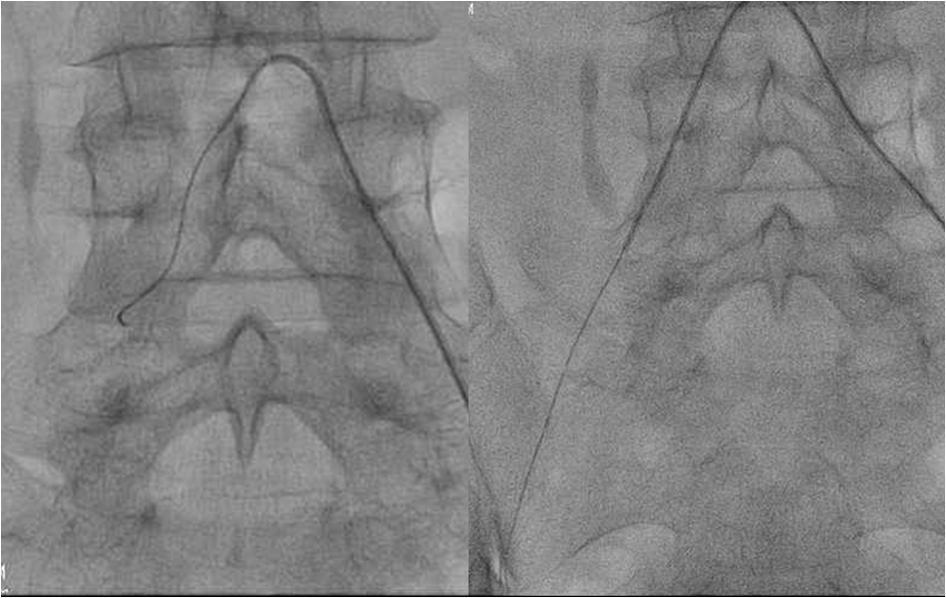
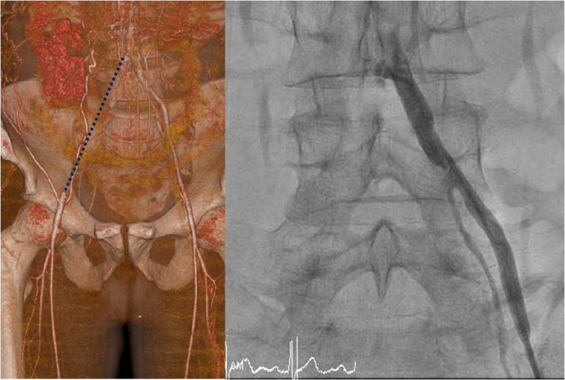
B
A
Fig 1. AngioCT and angiography Fig 2. 5Fr Omni and Glidecatheter

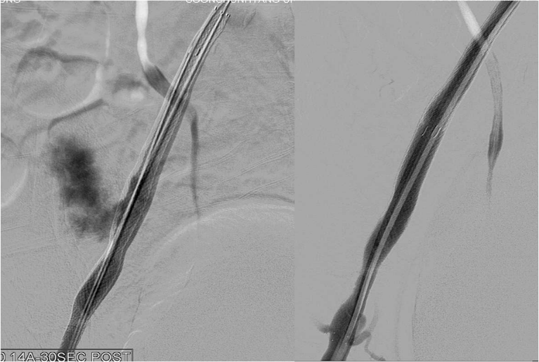
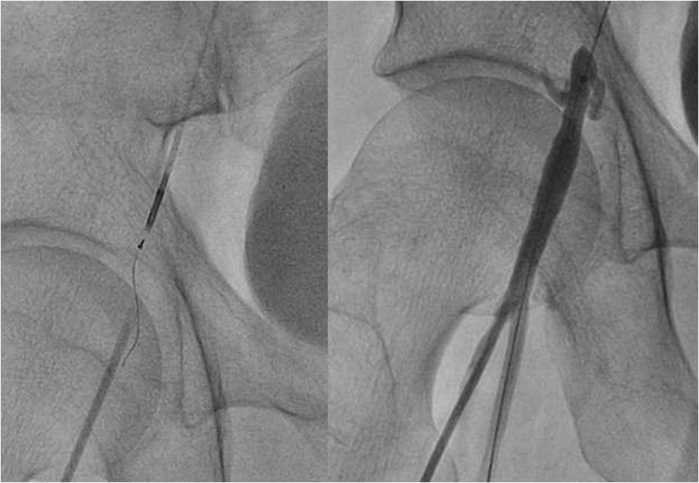
B
A
Fig 3. OUTBACK catheter and successful Re-entry Fig 4. A:Rupture B:Seal-off of perforation

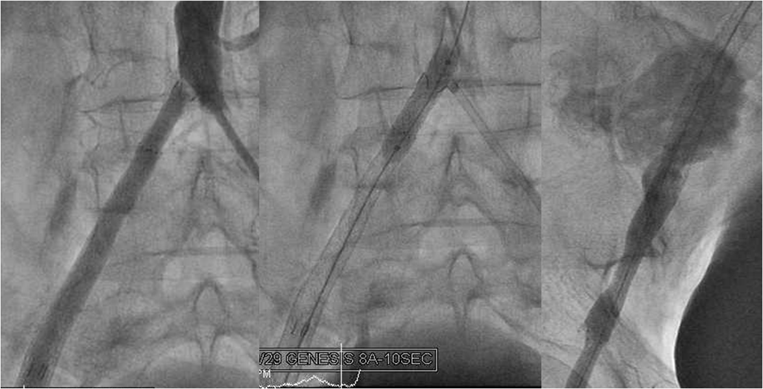
A
C
B
Fig 5. A:Uncovered lesion of the ostial CIA, B:Genesis stenting at ostial CIA, C:large amount of rupure

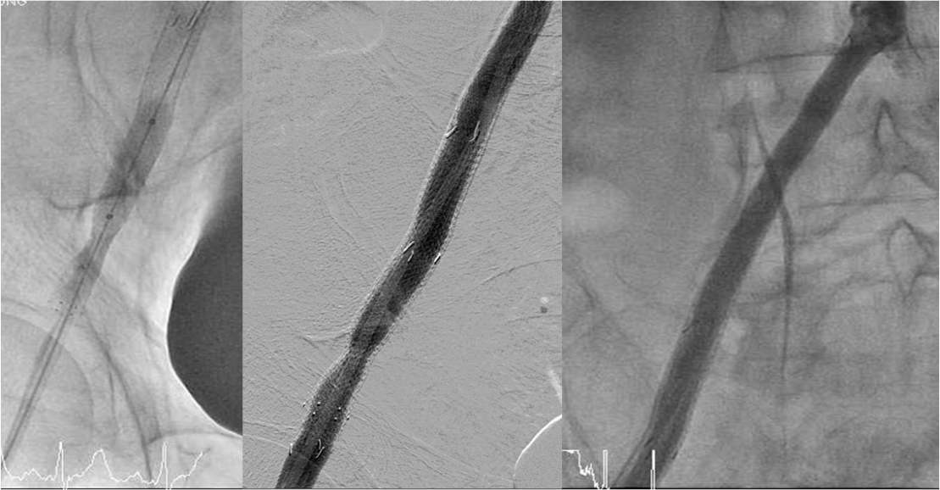
A
B
B
Fig 6. A:Ballooning for rupture portion, B:Successfully sealed rupture after additional Graft stenting

Discussion points

- What are the usual risk factors of perforation ?
- What are the determinant factors for perforation in this case ?
- What should have been performed after perforation in this case ?

