Author information
Presenter: OOO /영문
Operator: OOO /영문
Institution: OOO/영문

Case Summary
Title:
Life-threatening Rhadomyolysis complicating hybrid reperfusion for both legs acute limb ischemia after open surgical repair of abdominal aortic aneurysm.

Abstract
A 78-year old- male patient visited to our hospital for complaining of poor oral intake and abdominal discomfort. Preoperative CT angiogram showed Aneurysm with thrombus formation at infrarenal segment of abdominal aorta (maximal dimension of the aneurysm=6.4cm. Aneurysm extent to the left common iliac artery) (Fig. 1). Open surgical repair was done because of unsuitability for endovascular aortic repair. After nine hours of operation, acute limb ischemia signs at both legs were notified to me, while the patient was under ventilator therapy. Doppler showed no blood flow and thrombotic occlusion to both lower extremity and multiple segmental chronic total occlusion lesions at both superficial femoral artery and multiple atherosclerotic lesions at both below the knee. Because of unstable vital sign, further imaging study including computerized tomography was difficult.
Emergency hybrid operation was decided for life-saving because of unstable vital sign, deteriorated laboratory data. Hybrid operation was done through surgically exposed both common femoral artery successfully. For right leg, 1) thrombecotmy with Over-the-wire Fogarty Thru-Lumen Embolectomy Catheter from right iliac artery to right superficial femoral artery, and 2) stenting at middle superficial femoral artery and ballooning at below the knee lesions were done. For left leg, 1) thrombectomy with the Same Fogarty catheter, and 2) femoro-popliteal bypass with 6 mm vascular graft were done. (Fig. 2). After hybrid surgery, her legs became warm and strong dorsalis pedis pulses were palpable bilaterally. She was treated with intravenous heparin and prostaglandin E1 postoperatively

One day after surgery, the patient suddenly was still under ventilator therapy and became oliguric. His urine was dark red in her plasma creatinine increased from 1.09 to 2.65 mg/dL, creatine kinase (CK) level was over 15000 U/L on the next day. The patient was treated with continuous renal replacement therapy (CRRT) to keep adequate hydration. Both toes subsequently developed gangrene and swelling, and compartment syndrome was suspected (Fig. 3). Unfortunately, he subsequently developed multiple organ failure syndrome and died at Second day.

Discussion
1. Adequate preoperative assessment for abdominal aortic aneurysm
2. Adequate postoperative management for abdominal aortic aneurysm
3. How to prevent multiple organ failure by rhabdomyolysis as reperfusion injury

Key word
1. preoperative assessment and postoperative managment for abdominal aortic aneurysm treatment
2. Rhabdomyolysis
Fig
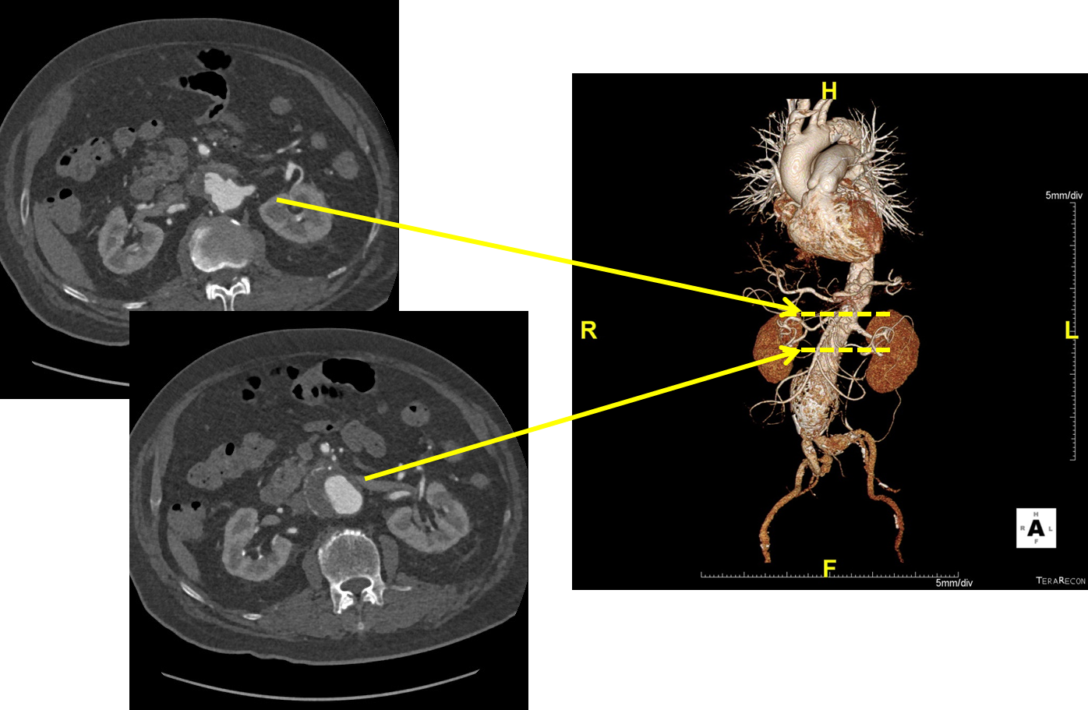
Figure. 1. Preoperative CT angiogram showed Aneurysm with thrombus formation at infrarenal segment of abdominal aorta (maximal dimension of the aneurysm=6.4cm. Aneurysm extent to the left common iliac artery)

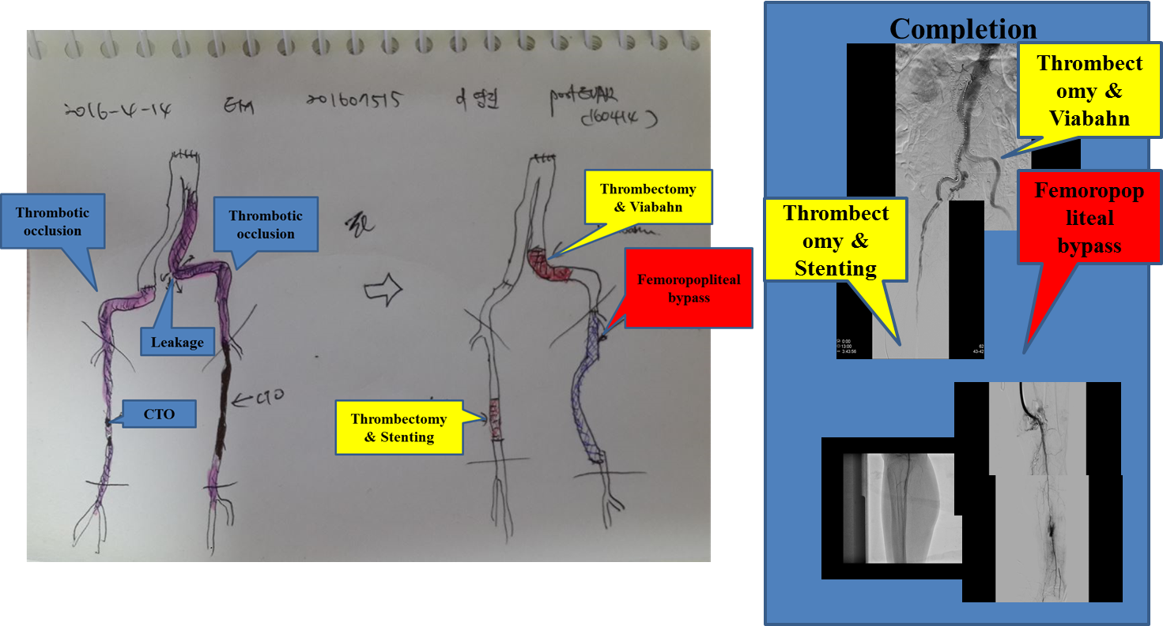
Figure. 2. Emergency hybrid operation was done. For right leg, 1) thrombecotmy with Over-the-wire Fogarty Thru-Lumen Embolectomy Catheter from right iliac artery to right superficial femoral artery, and 2) stenting at middle superficial femoral artery and ballooning at below the knee lesions were done. For left leg, 1) thrombectomy with the Same Fogarty catheter, and 2) femoro-popliteal bypass with 6 mm vascular graft were done.
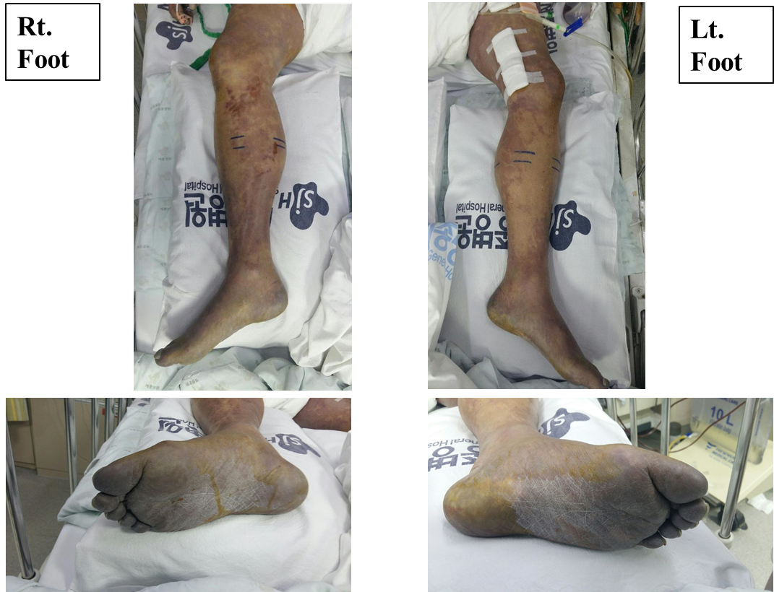
Figure. 3. Both toes subsequently developed gangrene and swelling, and compartment syndrome was suspected, even though the patient was treated with continuous renal replacement therapy (CRRT) to keep adequate hydration.

